Explore Light and Shadows Name:
Date:
1. Why is your shadow sometimes in front of you and sometimes behind you?
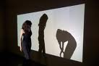

2. Can you see reflective material without light? Why?
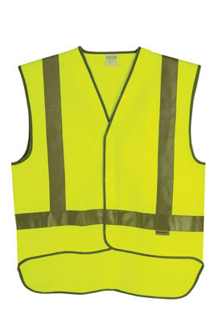
3. Is it possible to see without light? Why?
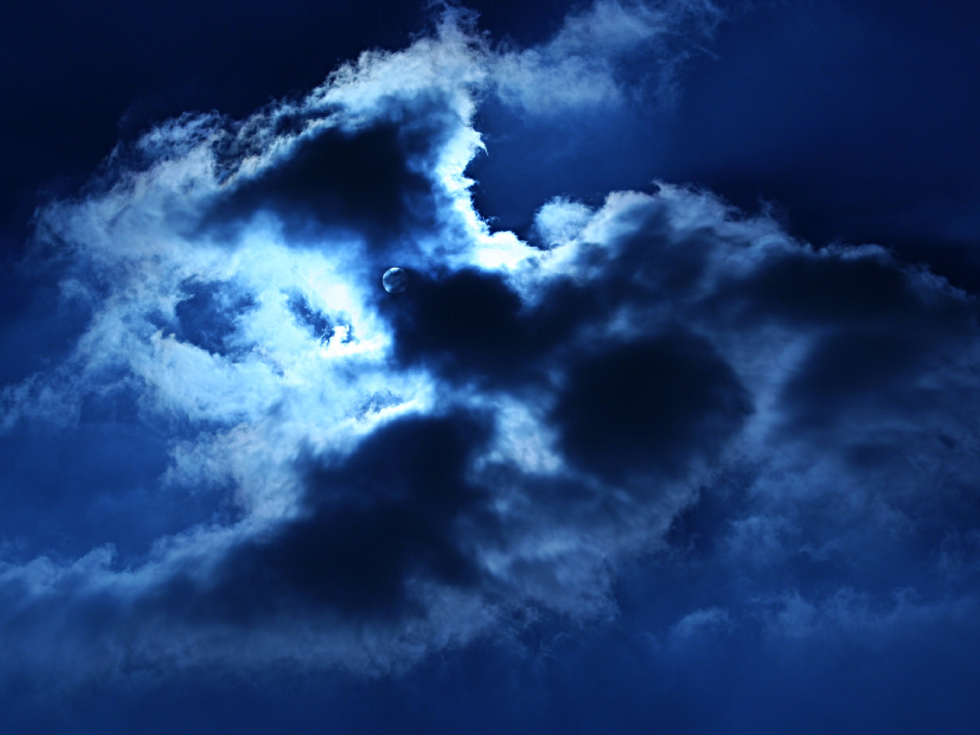

4. Make a silhouette of a friends head using the projector. How can you change the size of the shadow?
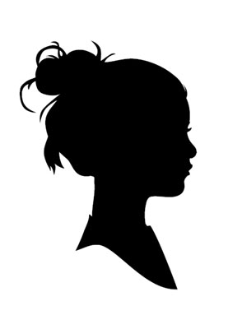

5. What happens to a shadow when you move it towards the light source?
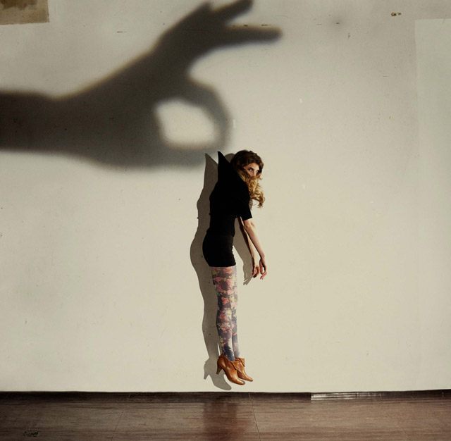

6. How many light sources do you know? List them.
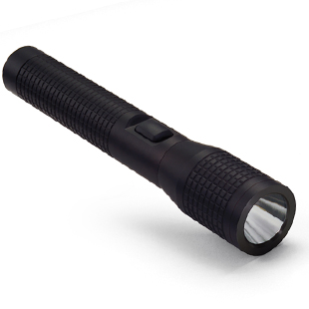

7a.What does it mean when a material is ‘opaque’?

7b.What does ‘transparent’ mean?

8. Why is the sun so important to life on earth?
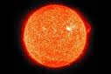
9. Can light only travel in straight lines or can it bend?
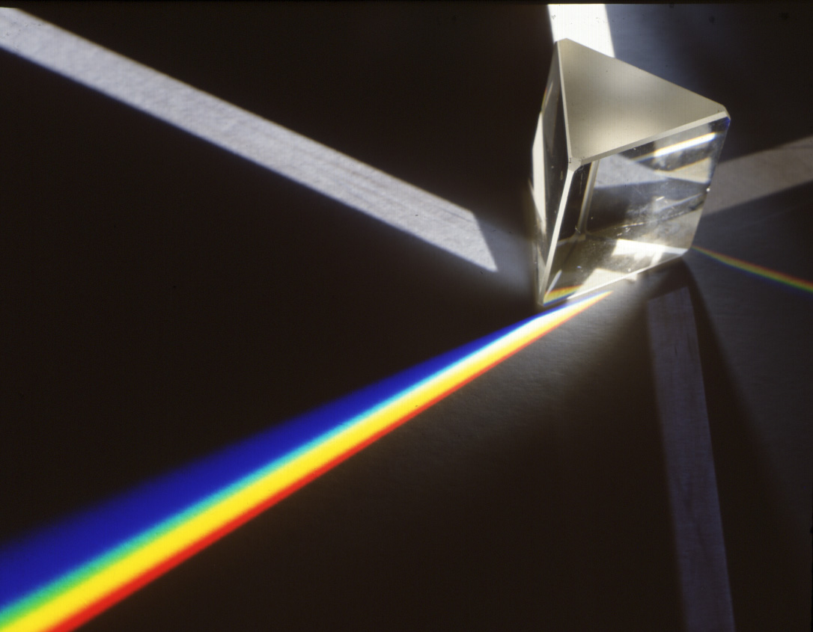

10. Why does the moon appear brighter at night?
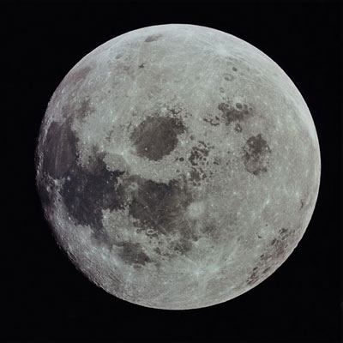

11. How is a shadow formed?
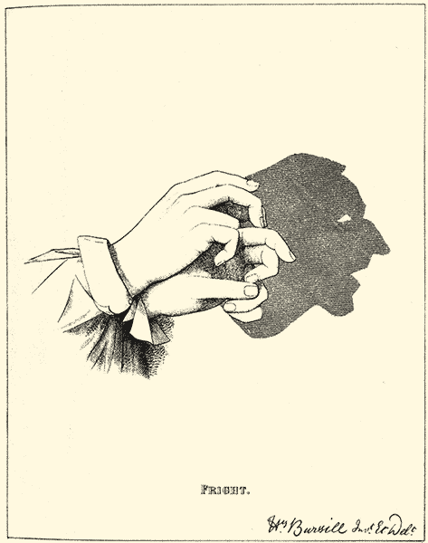

13. What happens when light hits a mirror?
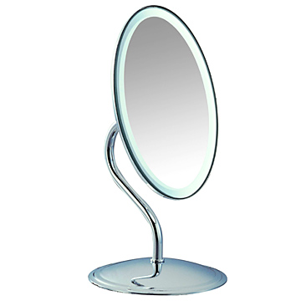

I know:
that light travels from a source
that light cannot pass through some materials, and how this leads to the formation of shadows
that light is reflected from surfaces
that we see things only when light from them enters our eyes

